British Car Day
Sunday - June 23rd 9:00 AM – 1:00 PM
Larz Anderson Auto Museum, 15 Newton St, Brookline, MA
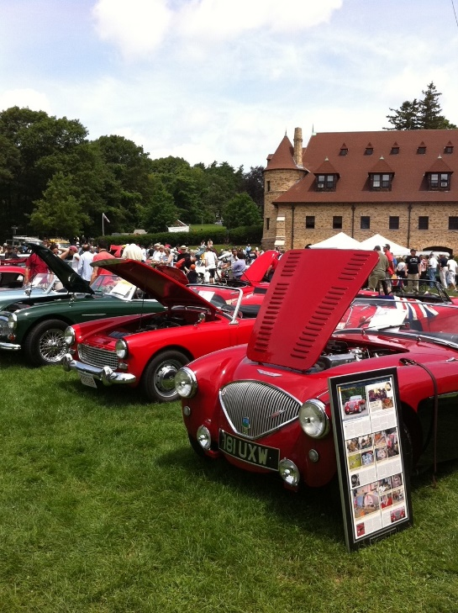
Join us for British Car Day, a fantastic gathering at the Museum in support of the Larz Anderson Auto Museum. We welcome all British automobile owners, no matter the make, model, or year – everyone's invited!
Feel the pride of showing off your British wheels, whether they're classic or contemporary – we love them all! It's a great chance to catch up with old pals and maybe even make some new ones.
The fun kicks off at 9 AM and keeps going until 1 PM, with the Museum staying open until 3 PM for your browsing pleasure. And of course, there'll be tasty food and drinks available to keep you fueled up for the day.

Car registration, online:
Driver only • $30 - Driver + 1 passenger • $40
Car registration, day-of:
Driver only • $40 - Driver + 1 passenger • $50

British Car Day | LAAM (larzanderson.org)

